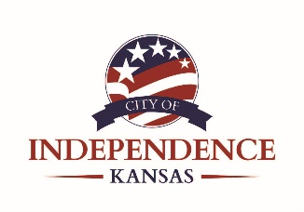

2025 Sales Tax Report

Sales and Use taxes are Independence's largest funding source. The City receives a portion of the overall sales taxes you pay within city limits (3%) for use as indicated below. The projected revenue generated from all sales and use taxes for 2025 is $7,500,000, which is more than double the amount of all ad valorem taxes generated for the City in 2025 ($3,664,092).

Sales Tax Breakdown | Percent
City of Independence General Fund Sales Tax | 1.00%
City of Independence Educational Sales Tax | 1.00%
City of Independence Special Use Sales Tax | 1.00%
General Fund Support | 0.25%
Debt Support | 0.31%
Economic Development | 0.05%
Building & Facility | 0.12%
Streets | 0.27%
CITY TOTAL | 3.00%
State of Kansas | 6.50%
TOTAL SALES TAX | 9.50%

The amounts listed in this report represent 1% Sales Tax Collections. The “receipts” reported from the State of Kansas to the City for any given month are from sales generated two months prior.

THANK YOU
For Supporting Local!

